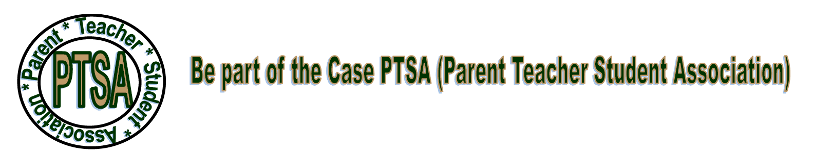
This isn’t your Elementary school PTSA
No pizza sales or movie nights! We know you’re busy so our goal is to provide useful information and opportunities to volunteer and be involved with your student’s school.
We have Educational Programs. We try to schedule 3-4 programs a year.
Not MEETINGS BUT PROGRAMS with a specific topic or presentation, such as a question and answer session with school or district leaders, information about helping our student plan beyond high school, etc. We want to make these helpful. You will come away with new information, connect with other parents, understand more about Case, and be able to communicate directly with administrators.
What activities is Case involved with?
We provide parent volunteers for coat check and refreshments at Homecoming, Winter Formal, and Prom or other events as needed. We provide financial support for things such as the Case Random Acts of Kindness Club, an annual scholarship, and projects that help boost school spirit and image (like the ACADAMIES/I.B./PROJECT LEAD THE WAY signs outside the main entrance). We do two staff appreciation luncheons each year. And we’re always open to suggestions and new ideas!
Your $10 membership ($7 for students)
Your membership gives you voting privileges and helps support Case PTSA and also PTSA’s efforts on the state and national level. But you don’t have to be a member to be involved and be a part of our activities. Please fill out this form and return it to the school at schedule pick up time or any time after school starts. Just giving us your name and email address helps us keep you informed.
We help keep you informed
Via emails and our Facebook page (J.I. Case PTSA). Please “like” and follow our page, and encourage other parents to do so too!
Thanks for your interest and support of Case PTSA.
Contact us if you have any questions or suggestions. We hope you and your student have a great school year!

President Vice President Treasurer Secretary
Alicia Ramirez Mandi Jutzronka Jessica Rothen Deb Redell
aliand0913@yahoo.com annymanny16@yahoo.com j.rothen@yahoo.com deb@redells.com
262-989-7113 847-508-3324 262-412-6076 262-497-6321

